3GPP TSG-RAN WG2 Meeting #133 R2-2600403
Gothenburg, Sweden, 9th – 13th February 2026

Agenda Item: 10.3.1.3
Source: MediaTek Inc.
Title: Contention-based BSR reporting
Document for: Discussion and decision

Introduction
In the previous meeting [1][2], we reached the following agreements on the user plane design. This document discusses design considerations and procedure for UL scheduling and scheduling information reporting such that eMBB’s data transfer latency can be reduced for 6G.
RAN2 #131bis
- 6G user plane should aim to reduce the radio and end-to-end latency for general services (including eMBB)
- Support at least the following scheduling schemes: dynamic grant and configured grant. Further study configured grant.
- Study need for scheduling enhancements to address the SR/BSR/DSR latency
RAN2 #132
- RAN2 will study solutions on how to improve latency and UL resource efficiency of scheduling (including contention based schemes).
- RAN2 study on CB UL will assume the following:
  - Baseline for comparison is at least the normal SR/BSR functionality we have today
  - Companies can highlight the similarities and differences between the proposed solutions with what we have today for 5G (e.g. shared CG resources with or without retransmissions, 2-step RACH like scheme without preamble etc).
  - Discussion on further assumptions is FFS based on the solutions identified.
- Study mechanisms to provide scheduling information (including at least buffer status reporting, delay status reporting). FFS other scheduling information needed depending on traffic/services. Aim to unify the framework if possible, after some progress on the detailed functionalities.

Discussion

Uplink scheduling latency reduction
When an NR UE has uplink (UL) data and no UL resources available to transmit the data, it transmits a scheduling request (SR) to the base station using pre-allocated dedicated SR resources to indicate its need to acquire UL resources. On SR reception, the base station only knows that this UE has ‘some’ data to transmit but does not know how ‘much’ data is to be transmitted. To avoid wasting radio resources, the base station usually allocates a small grant to the UE for it to indicate the amount of data in its UL buffers using a Buffer Status Report (BSR). On reception of the BSR, the base station can allocate an appropriately sized grant to the UE to transmit its data as illustrated in Figure 1. The current mechanism to acquire UL resources introduces significant latency to the start of an UL transmission. Table 1 provides a typical NR configuration in the field related to UL resource acquisition delays.
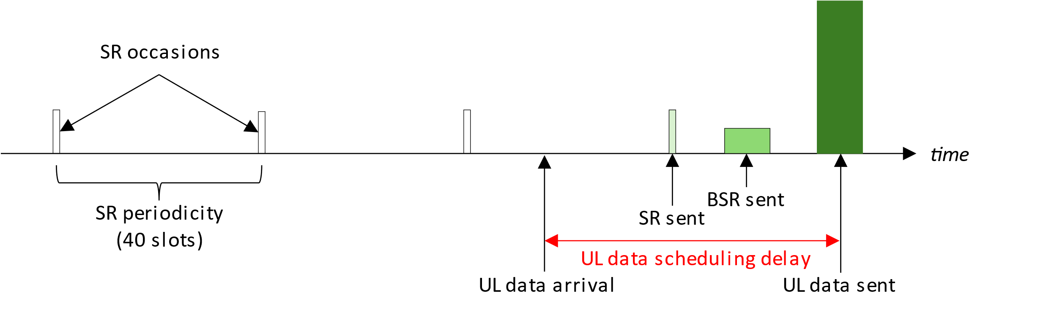
Observation 1: Initiating uplink scheduling of eMBB data in NR faces significant delays due to SR unavailability.
Figure 1: Typical UL resource acquisition delays in NR
Steps | Values
0. UL data arrival | -
1. Average SR delay | 10ms (20 slots)
2. UL DCI | 0.5ms (1 slot)
3. Scheduling delay (K2) | 1ms (2 slots)
4. BSR transmission | 0.5ms (1 slot)
Table 1: Typical UL scheduling configuration in NR
To counter this delay, NR introduced the configured grant (CG) feature with which the base station pre-allocates periodic UL resources to a UE. While useful for services with periodic traffic of deterministic size such as URLLC or voice calls, it is not spectrally efficient to use such a mechanism to serve aperiodic eMBB traffic, as resources need to be periodically reserved for specific UEs on the off chance that it may be used. The cost of reserving such dedicated resources for a UE is provided in Table 2. Therefore, we seldom observe CG deployed in NR. One way to resolve low resource efficiency problem is to make the resources shared with multiple UEs, as shown in Table 2 and also mentioned in agreements during RAN2 #132 meeting report [2].
Observation 2: “Dedicated” CG is seldom deployed in NR due to low resource efficiency.
 | Resource Elements (REs) overhead per UE
SR + BSR (Dedicated to 1 UE) | 12 + 168 = 180
BSR (Dedicated to 1 UE) | 168
BSR (Shared by N UEs) | 168 / N
Table 2: Physical layer resource cost of different approaches to UL scheduling
Instead, what is often seen in NR is that base station randomly schedules small UL grants to the UE. Such a mechanism, called “pre-schedule”, try to target the SR delay in step 1 of Table 1. Avoiding step 1 delays would only be possible if the base station can perfectly predict UL data arrival timing. However, if the base station cannot achieve ‘perfect’ prediction, step 1 delay will still exist while radio resources are wasted as well. Furthermore, if the UE is not configured to skip UL transmissions when UE has no data, “pre-schedule” mechanism also results in more UE power consumption.
Ideally, the base station should be aware of UL data as soon as it arrives at the UE i.e., steps 1-3 in Table 1 are skipped and step 4 is initiated on data arrival. This would require the presence of UL resources that are always available for the UE to use for BSR transmissions while remaining spectrally efficient (i.e. avoiding the pitfalls of CG). We propose the use of a pool of always-available UL resources that are shared by several UEs. By sharing the resources among different users, the base station can schedule always-available resources to tackle SR availability delays while keeping the cost per user down as shown in Table 2. When UL data arrives at the UE, it would immediately send a BSR on this shared resource to acquire UL resources early as illustrated in Figure 2.
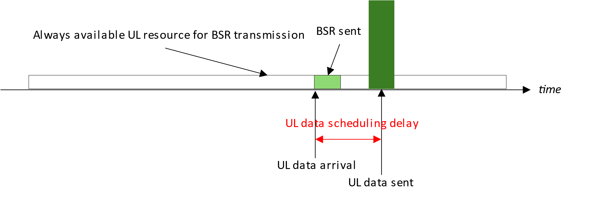
Observation 3: Skip SR (Scheduling Request) procedure can significantly reduce the UL latency.
Figure 2: Proposed mechanism for early UL resource acquisition in 6G
Proposal 1: Always-available contention-based uplink resources are introduced in 6G to enable early BSR transmission to reduce uplink scheduling latency.
Such a shared contention-based resource pool needs to be carefully designed to achieve a balance between low collision probability and keeping the resource overhead per UE to a minimum. The contention-based uplink resource pool can be configured by base station to UE(s) in advance, like NR CG mechanism or it can be indicated by base station via DCI anytime as “pre-schedule” mechanism. No matter how this contention-based resource pool is configured or indicated, this is one topic that RAN2 need to study. If RAN2 decide to use DCI to indicate the contention-based resource pool, RAN2 need to inform RAN1 about this in advance.
Proposal 2: RAN2 to study the mechanism that how the contention-based uplink resource pool is configured or indicated to UE(s).
- Option 1: Configured via RRC message.
- Option 2: Indicated via DCI.
The latency performance of CBUL is highly related to the resource pool size and the UE number try to do BSR transmission simultaneously as shown in Figure 3. As UE number increases under the same size of contention-based resource pool, the average delay increases due to BSR reattempt. Therefore, it is important the contention level should be maintained by base station below a certain level. It is easy to understand, if the resource pool size is larger, the contention level is lower. Therefore, RAN2 need to study which dimension can be used to increase the resource pool size. The contention-based resource pool can consist of time domain, frequency domain and DMRS sequence domain.
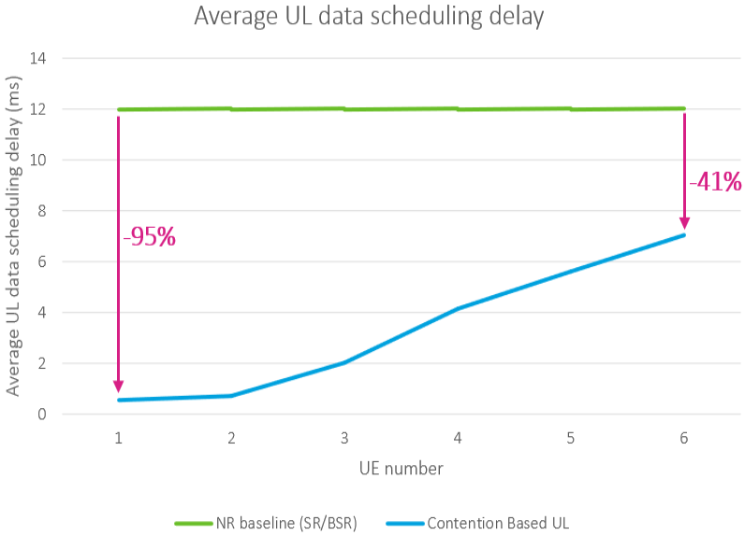
Figure 3: Average UL data scheduling delay comparison, NR baseline (SR/BSR) vs. Contention Based UL (CBUL)
Observation 4: The latency performance of CBUL is highly related to the contention-based uplink resource size and UE number.
Proposal 3: RAN2 to study the mechanism that base station can use to maintain the contention level below a certain threshold.
When considering sharing resources amongst UEs, an important consideration is the identification of different UEs that are in contention with each other. One simple solution to this problem is to carry UE’s C-RNTI in the payload. Of course, we could also ask RAN1 whether other mechanism can be used to identify different UEs. However, this could also mean differences in the design of the channel used for contention-based uplink transmissions. This is an aspect that would need to be considered by RAN1 as part of their physical channel design and therefore would require delivering this requirement to RAN1 early. With this UE ID information, base station can distinguish different UEs by this UE ID. Therefore, base station can give a proper grant size to a certain UE by BSR and UE ID.
Proposal 4: In order to identify different UEs, a UE ID is included in the transmission together with BSR. FFS what UE ID is.
Since base station can only distinguish different UEs by UE ID in payload (e.g., C-RNTI, if RAN1 doesn’t provide other mechanism to distinguish different UEs), the base station can not know which UE try to send BSR, if the base station fails to decode the payload. Therefore, the BSR reattempt can only be triggered by UE itself by a timer.
Proposal 5: If no response from base station is received for a period of time after a BSR transmission, a new BSR transmission is attempted (i.e., no need to retransmit previous old BSR).
In contention-based UL BSR transmission, the worst case is that BSR already been retransmitted too many times. Of course, according to Proposal 3, we expect base station can design a good mechanism to avoid too much BSR retransmission. Any mechanism design needs to very robust, a mechanism for worst case should be considered as well. Based on Observation 3, we don’t expect UE fallback to legacy SR procedure, because SR introduce significant latency. A simple solution is, RAN2 can define a counter upper bound for BSR retransmission, once the number of BSR retransmission exceed the upper bound, UE should fallback to RACH procedure.
Proposal 6: UE fallback to RACH procedure when the number of BSR attempts exceed a threshold.
We summarize the overall CBUL procedure as below and in Figure 4.
- Step 0. Base station (BS) indicated the Contention-Based (CB) UL resource
- Step 1. When UE(s) has UL data, UE randomly choose one Resource Block (RB) to transmit BSR and UE ID.
- Step 2. Base station received the transmission from UE(s)
  - If base station successful decode the transmission from UE, base station can send an proper UL grant size to UE according to the BSR and UE ID.
  - If base station can not decode the transmission or fail to receive transmission, base station can not know which UE send the BSR. The only way is UE try another BSR transmission when timer expires (i.e., go back to Step 1).
- Step 3. If UE reattempt BSR too many times, UE fallback to RACH procedure.
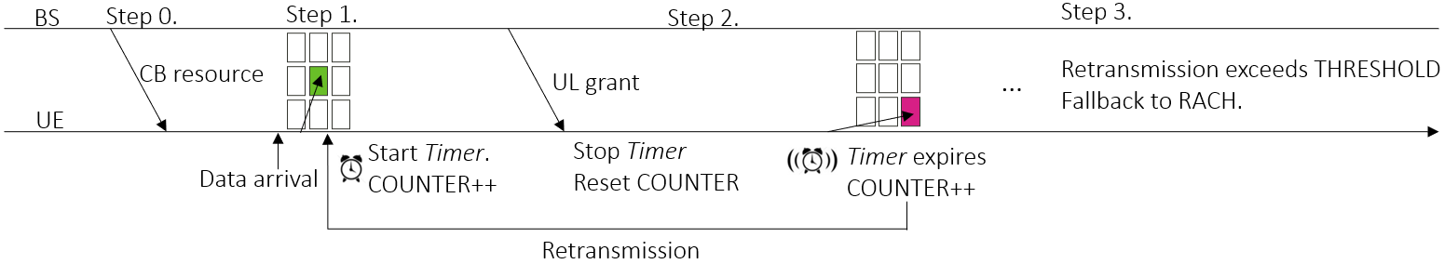
Figure 4: Overall procedure for CB UL mechanism
According to [3]’s observation, the traffic in real networks typically is very bursty and consists of a mixture of small (96%) and large (4%) packets, transmitted in short or long sessions. Therefore, we show some preliminary latency performance of small and large packets with our proposed contention-based UL (CBUL) scheduling mechanism and legacy NR SR/BSR solution in Figure 5 and Table 3. The packet size and arrival rate will be changed at the same time to remain the same traffic loading. Other simulation parameters can be found in the Appendix.
- Small Packet case: after BSR transmission, the small packet can be finished within 1 slot transmission.
- Large Packet case: after BSR transmission, the large packet needs 10 slots to finish the transmission.
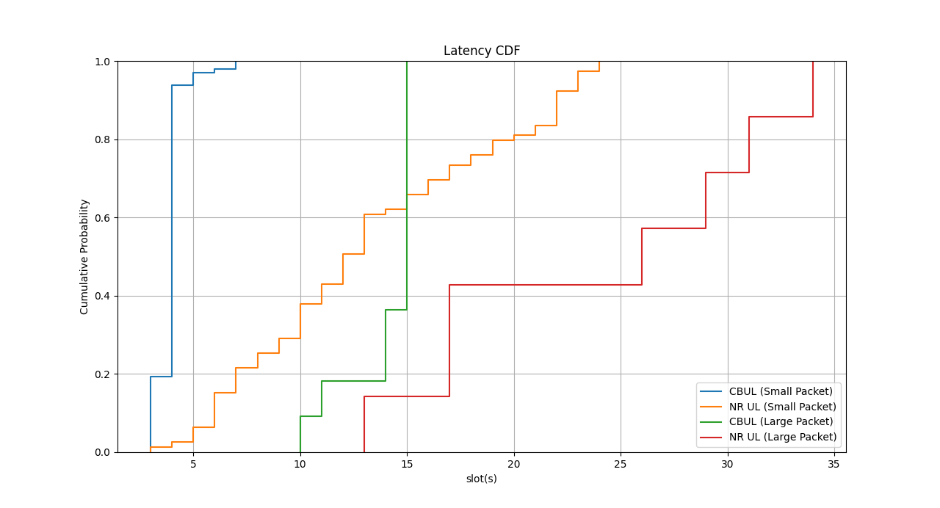
Figure 5: Latency CDF of NR UL and CBUL with Small Packet and Large Packet
 | Traffic Type | Mean Latency (slots) | Latency Gain
NR UL | Small frequent Packet | 13.25 | -
 | Large infrequent Packet | 23.86 | -
CBUL | Small frequent Packet | 3.92 | -70%
 | Large infrequent Packet | 14 | -41%
Table 3: Mean latency performance of NR UL and CB UL
From Table 3, we can observe that for small packet (96%) case, we can achieve 70% latency reduction. For large packet case, we can also achieve 41% latency reduction. Therefore, the latency reduction gain of CBUL mechanism applies to all types of traffic and services.
According to Proposal 2 and Proposal 4, it might have impact to RAN1, we need to acquire and check the feasibility with RAN1.
Proposal 7: Send an LS to RAN1 to take the following design requirements into consideration:
- Contention-based UL PUSCH resource designed for early BSR reporting

Conclusion
In this contribution we have the following proposals based on these observations:
Contention-Based UL
Observation 1: Initiating uplink scheduling of eMBB data in NR faces significant delays due to SR unavailability.
Observation 2: “Dedicated” CG is seldom deployed in NR due to low resource efficiency.
Observation 3: Skip SR (Scheduling Request) procedure can significantly reduce the UL latency.
Observation 4: The latency performance of CBUL is highly related to the contention-based uplink resource size and UE number.
Proposal 1: Always-available contention-based uplink resources are introduced in 6G to enable early BSR transmission to reduce uplink scheduling latency.
Proposal 2: RAN2 to study the mechanism that how the contention-based uplink resource pool is configured or indicated to UE(s).
- Option 1: Configured via RRC message.
- Option 2: Indicated via DCI.
Proposal 3: RAN2 to study the mechanism that base station can use to maintain the contention level below a certain threshold.
Proposal 4: In order to identify different UEs, a UE ID is included in the transmission together with BSR. FFS what UE ID is.
Proposal 5: If no response from base station is received for a period of time after a BSR transmission, a new BSR transmission is attempted (i.e., no need to retransmit previous old BSR).
Proposal 6: UE fallback to RACH procedure when the number of BSR attempts exceed a threshold.
Liaising with other groups
Proposal 7: Send an LS to RAN1 to take the following design requirements into consideration:
- Contention-based UL PUSCH resource designed for early BSR reporting

References
- R2-2508002 - RAN2#131bis Meeting Report (ETSI MCC)
- R2-2600002 - RAN2#132 Meeting Report (ETSI MCC)
- R1-2505650 - Overview of the 6G air interface, Ericsson

Appendix – Simulation assumption
Parameters | Values
Number of BS | 7 BSs, each BS with 3 sectors.
Inter-BS distance | 500m
Carrier frequency | 4GHz
Bandwidth | 100MHz
BX Tx power | 44dBm
BS antenna height | 25m
BS receiver noise | 5dB
Number of UE | Total 210 UEs, 10 UEs per sectors
UE Tx power | 23dBm
UE receiver | MMSE-IRC as the baseline receiver.
Feedback assumption | Ideal
Channel estimation | Ideal
Traffic type | Small frequent Packet: 20KB, 10 packet per second  Large infrequent Packet: 200KB, 1 packet per second
BSR MAC CE size | 1 bytes
C-RNTI MAC CE size | 2 bytes
Occuied RB of BSR MAC CE and C-RNTI MAC CE | 1 RB (3 bytes)

